MSI AnnData creator:
The function ann_data_creator was a high-level function that took the MSI data in the imzML and ibd formats and metadata describing the sample and employed several functions to construct an AnnData object enhanced with spatial coordinates, m/z features, and experimental metadata. The detailed explanation of the incorporated functions is going to be discussed here:

ImzML and ibd file reader and parser:
The read_imzml_ibd function was used to extract mass spectrometry imaging (MSI) data from paired imzML and ibd files. These files stored both the metadata (such as spatial coordinates, offsets, and data types) and the raw spectral data (m/z values and corresponding intensities for each pixel in a tissue image).
The imzML file, written in XML format, provided structured metadata describing each spectrum (i.e., each pixel in the image). The function began by parsing this file and identifying all spectrum elements, where each one represented a specific (x, y) position on the tissue and included pointers to the actual m/z and intensity data stored in the corresponding .ibd file.
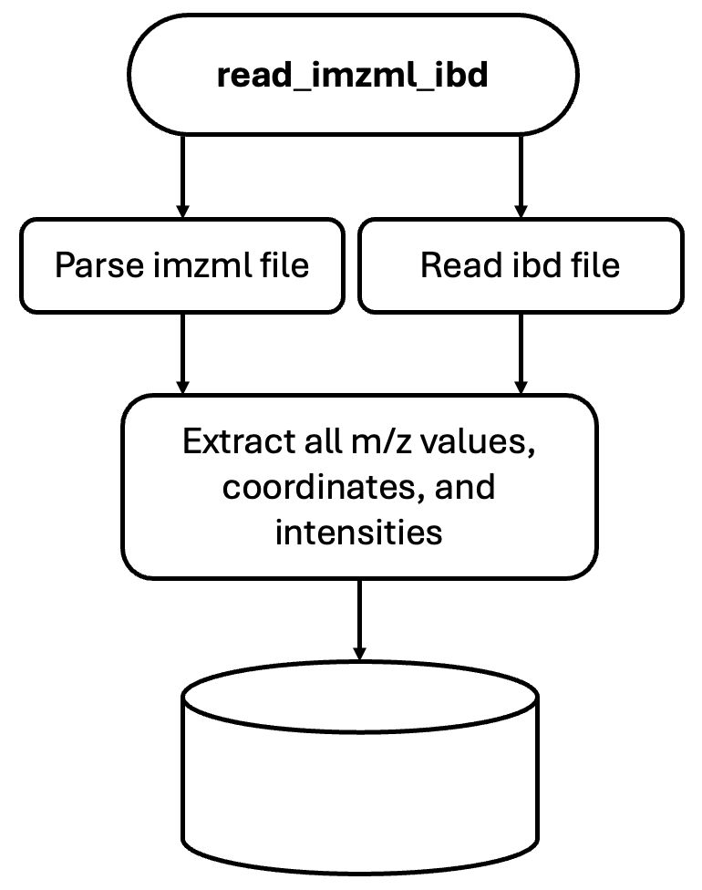
For each spectrum, the function extracted:
- The spatial (x, y) coordinates.
- Offsets and lengths that indicated where to find the binary m/z and intensity arrays in the ibd file.
Two helper functions were used:
- get_dtype: Determined the data type (e.g., 32-bit float, 64-bit integer) of the binary arrays based on controlled vocabulary metadata in the imzML file.
- read_ibd: Used the offsets and data types to read binary chunks from the ibd file and converted them into NumPy arrays.
The main loop iterated through all spectra and used these helper functions to extract m/z and intensity data from the ibd file. For each spectrum, the data—m/z values, intensities, coordinates, and an index were stored in dictionaries under the keys "mzs", "intensities", "coordinates", "sample_numbers", and "row_numbers".
Finally, the coordinates were normalized by subtracting the minimum x and y values, effectively translating the coordinate system so that the image started at (0, 0). This normalization step was useful for consistent visualization and spatial indexing.

CSR matrix creator:
The create_csr_matrix(data) function was used to transform mass spectrometry imaging (MSI) data into a sparse matrix format, which is more memory-efficient and better suited for processing large datasets where most intensity values are zero. Also, this format made data possible to use tools like Scanpy and Squidpy, which were designed for AnnData format.
This function received output from read_imzml_ibd function as input. First, it combined all m/z values and found all unique m/z values across the entire dataset. This step was so important because there were a great number of common m/z values among pixels. These unique m/z values were going to be the features (column names) in the new data structure for further processing. The function accomplished this by building a dictionary that mapped each unique m/z value to a unique column index in the sparse matrix. For the row index, the function created a list of coordinate data, which stored the x, y spatial position of each pixel, and it used the pixel index in the list as a row index. Then, it created three lists and filled them by looping over all m/z for each pixel and recording the row index, column index, as well as a non-zero intensity value itself.
The function utilized the SciPy library and regarded three lists to create a Compressed Sparse Row (CSR) matrix. The matrix had:
  - Rows: one per pixel/spectrum
  - Columns: one per unique m/z value
  - Entries: the intensities of each m/z in each pixel (non-zero only)

AnnData creator:
This block of code constructed an AnnData object for the data, forming pixel-level spectra into a structure compatible with Scanpy or Squidpy for downstream analysis. It constructed an AnnData object and its metadata using the sparse matrix and lists related to the x and y coordinates extracted from the coordinates array. Accordingly, it created Variable Metadata and added an explicit column 'mzs' and stored the list of unique m/z values. At the end, it allocated the full array of coordinates (x, y) to obsm['spatial'], which was the standard location for spatial coordinates in Scanpy/Squidpy. The obsm['spatial'] was used for spatial plotting and analysis (e.g., region masking, spatial clustering).

Blank image creator:
The setup_spatial_data function initialized spatial metadata for a blank tissue image and stored it inside an AnnData object (adata). This setup was necessary for tools like Scanpy and Squidpy that expected spatial context for visualizations. This function received an AnnData object and the desired image size in centimeters and the desired image resolution in centimeters per pixel. It created a blank RGB image of zeros based on the image size in pixels. This acted as a placeholder image for spatial plotting. Then, it assigned spatial metadata by storing it as a dictionary in the uns['spatial'] of the AnnData

Sample metadata adder:
The metadata function added descriptive metadata (sample-specific information) to an AnnData object that contained mass spectrometry imaging (MSI) or similar spatial omics data. The function took an AnnData object and four desired metadata attributes as input:
  - sample_num: an identifier for the individual sample.
  - batch_num: an identifier for the batch or slide number.
  - age_group: a label like "Young" or "Aged".
  - disease_status: a label like "Control" or "AD".
These values explained the experimental conditions associated with this dataset. The function added the new metadata columns to the existing observation metadata in the AnnData object by joining on the index. This improved the dataset with relevant experimental labels, making downstream analysis easier and more informative (e.g., for grouping, visualization, differential analysis).

